The original from which the below is derived, without markups, was at http://elainemeinelsupkis.typepad.com/ezmoneymatters/2008/04/federal-reserve.html on July 1, 2010.
Markup by Frederick N. Chase using only i) emphasis (red, bold, underline, or font size) and ii) bracketed pink commentary.

Federal Reserve History
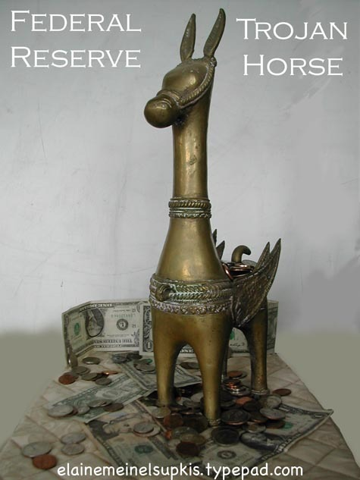
April 2, 2008
Elaine Meinel Supkis
The onrush of news is taking a small break here. So it is time to look backwards rather than forwards. The Federal Reserves consortium of private owners are involved in a massive coup. The 200 pages they submitted to a befuddled Congress is a take over of our entire financial systems. It takes quite a few days to write up an elaborate proposal. Note that these people came prepared! Most Americans know virtually nothing about the history of banking and the government. Yet, if we look at old, musty newspapers pre-Federal Reserve, we can clearly see the debates over the value of money, type of money and handling of money was at the top of all political debates and attracted huge crowds. Now, people can't understand even a small part of this business. This is deliberate. The last thing the people who foisted the Fed on us want, is a debate. As Ron Paul is very aware.
A reader kindly sent me this link. I get many emails a day and many of them have great information. I want to thank everyone for this. The link below is about a real Supreme Court case. The financial systems we have today are the result of many laws and court ruling stretching back to the very foundation of the United States. Things are not 'set in stone' unless the Supreme Court sets it in cement.
Court Rules Federal Reserve is Privately Owned
Lewis v. United States, 680 F.2d 1239 (1982)
1. United States
There are no sharp criteria for determining whether an entity is a federal agency within meaning of the Federal Tort Claims Act, but critical factor is existence of federal government control over "detailed physical performance" and "day to day operation" of an entity. . . .
2. United States
Federal reserve banks are not federal instrumentalities for purposes of a Federal Tort Claims Act, but are independent, privately owned and locally controlled corporations in light of fact that direct supervision and control of each bank is exercised by board of directors, federal reserve banks, though heavily regulated, are locally controlled by their member banks, banks are listed neither as "wholly owned" government corporations nor as "mixed ownership" corporations; federal reserve banks receive no appropriated funds from Congress and the banks are empowered to sue and be sued in their own names. . .
3. United States
Under the Federal Tort Claims Act, federal liability is narrowly based on traditional agency principles and does not necessarily lie when a tortfeasor simply works for an entity, like the Reserve Bank, which performs important activities for the government. . . .
4. Taxation
The Reserve Banks are deemed to be federal instrumentalities for purposes of immunity from state taxation.
5. States Taxation
Tests for determining whether an entity is federal instrumentality for purposes of protection from state or local action or taxation, is very broad: whether entity performs important governmental function..
The conspirators who created the Federal Reserve chose the name as a disguise. The very name, 'Federal Reserve' is a Trojan Horse. Within this seemingly public central bank is actually a bunch of armed soldiers who aren't even bankers! There are some bankers involved in this raiding party. But the Trojan Horse also holds speculators, investors an old royals we thought we got rid of long ago! The identities of these raiders is kept as secret as possible. This isn't the seemingly small number of regional Federal Reserve banks, either. They are part of the front, they are the legs, head and body of the Trojan Horse designed and built by people like Vanderbilt and JP Morgan back at Jekyll Island 100 years ago.
There was virtually no debate in Congress and CERTAINLY none nationally or in the media before the Federal Reserve wheeled its Trojan Horse into Congress and then the White House. Any Cassandras who caught sight of this big machine being wheeled in were ignored.
November 19, 1907
EAGER TO TAKE FEDERAL NOTES;
President Receives Indorsement of Plan for $150,000,000 Currency Relief. $25,000,000 FOR NEW YORK Of the New Three Per Cents, Which May Be Used as Security for New Circulation.
PERHAPS AS RESERVE, TOO
News of the New Issues Employed Successfully in Buffalo to Check a Bank Run.
Immediate and approving response has been received from all over the country to the action of the President and Secretary Cortelyou in announcing the sale of $50,000,000 of Panama Canal bonds and the issue of $100,000,000 of treasury notes as a means of restoring public confidence and putting an end to the money stringency
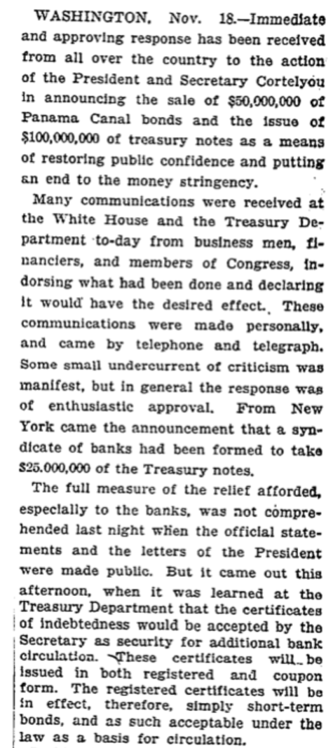
This article from 1907 shows us clearly that the exact...yes...the VERY SAME measures used back then, exactly 100 years ago, are the ones used today...BY THE FED, not the government, to save the speculators on Wall Street! This amazing repeat of history shows us, we went in this big circle. Only it wasn't a circle, it was a spiral, downwards. Because the government, this time around, isn't solvent and has no way of getting out of debt or even living within its own means. Note how the government issued bonds and then sold these to the bankers in order to get the bond market going again. Note that the Federal Government was willing to accept whatever papers the bankers held as security for these sales! And these would all be 'short term bonds' that could be rolled over by the government.
Now, it is rolled over by the Federal Reserve who gets to pick and choose when and how to do this...WITHOUT DEBATE. And this is the key phrase here. We may debate with Bernanke but he doesn't have to LISTEN to us! He can choose to do things IN THE MIDDLE OF THE NIGHT. As we see over and over again. He pops out of bed like some sort of vampire and goes to work when the rest of us are asleep. We may like or hate what he cooks up at 3 am but we certainly have no feed-back mechanism. We just have to live with it. And of course, 99.9% of his midnight rescues are aimed at saving the very rich, not the very poor or anyone below billionaire status. They are the ones who call him at 3 am screaming to be saved. We can call him and his phone is either busy or we get a message, 'Sorry, we cannot process this call. The Federal Reserve isn't owned by you. Only owners may call this number.'
The Jekyll Island conspirators put forwards their central banking plan that would create a bank that was NOT a central bank but would be a Trojan Horse that would take control of the currency out of the hands of the Treasury and park it inside a system that had few political controls by popular politicians who were not bankers. They disguised this new law by calling it a 'Currency reform bill' rather than 'Creating a new banking system the government can't control bill'. This was made even more opaque by calling it the Owen/Glass Act. The Democrats fought hard to make this bill all about making a central bank under Federal control. But the bankers were furious about all this.
August 1, 1913
ADVISORY BOARD OF BANKERS
Democrats Again Alter Reserve Plan -- Eagle Assails Bill.
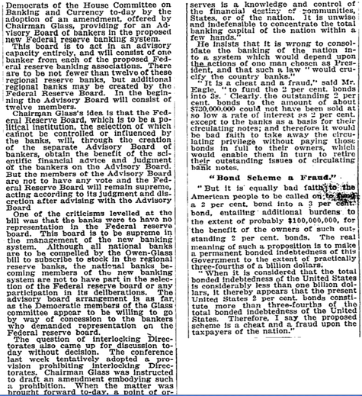
Chairman Glass wanted the bankers to be ADVISORY only. And he maintained that the Federal Reserve was to be POLITICAL. Meaning, Congress and the President would be the ultimate source of power, not the bankers. They can only give their opinions. Not unilaterally dictate things. This, of course, infuriated the banking community. They could see all their schemes going down the drain! It was summer, yet the difficulties of pushing their Trojan Horse through the doors of Congress was diminishing rapidly as more and more non-bankers [ie: farmers and manufacturers] got the ear of their representatives.
October 10, 1913
BANKERS' VIEWS IN SENATE
A general discussion of the currency situation on the floor of the Senate this afternoon made it plain that there was no considerable sentiment in that body for bringing pressure to bear on the Banking and Currency Committee to induce a early report
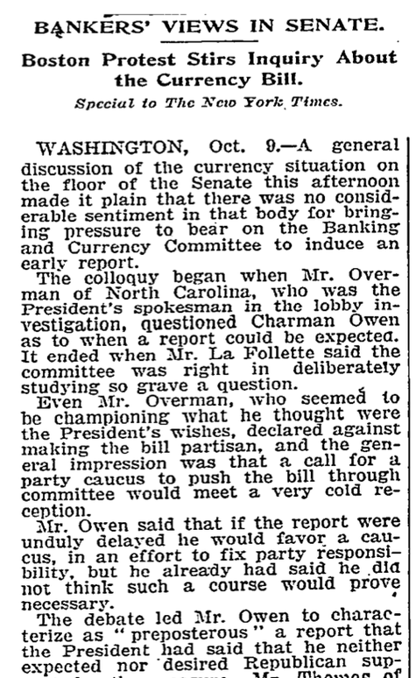
Now we are in October of 1913. The bankers have been using all their tools to get a grip on things. The Democrats were dragging their feet. The Trojan Horse was stuck in the doors of the Senate! The bankers were inside, sweating with fear and anger. How can they shove this thing through? Up until this point in time, the debate over currency was mostly between the gold fanatics and the silver nuts. In other words, Eastern bankers and Western farmers and miners. As I will show in a following article today, the gold/silver debate roared along for 100 years rising to a crescendo right before this bill was submitted to Congress.
There was a great desire for 'bipartisanship' in passing this bill which totally took the debate about currency types and values out of the hands of the public and shuffled it away inside of the banking vaults of the top investing bankers. The Republicans didn't want all the blame for this bill on their shoulders. They were desperate to get the Democrats to be party to this raid on the Treasury's powers.
Here is a second article from the same paper, the same day:
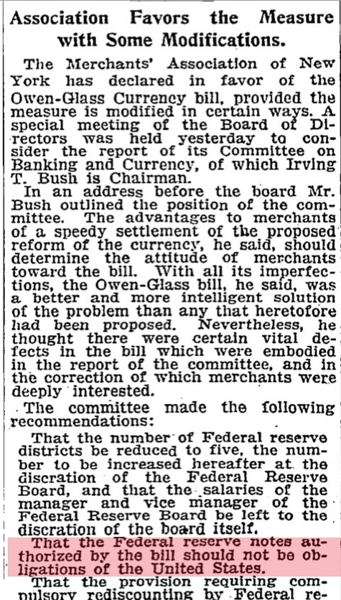
The merchants were worried about a repeat of the Civil War paper money fiasco. They worried that banking missteps would translate into sudden taxes. They also worried about...get this...INFLATION. The support for this bill was rising only because of changes introduced to prevent these things from happening.
Note how this bill was referred to as a 'currency bill.' Not a debate about a central banking system. The fact of the matter is, the writing on the paper currency issued by the Treasury was to be altered. As I pointed out in a previous article where I examined paper money in the past, 'History of Silver/Gold Ratios' I posted pictures of paper money we own that goes back to the Civil War. These things were contracts, not 'money'. The earliest ones listed all the laws relevant to the issuing of these government bonds. The first ones had a lot of script explaining how this was not 'money' but a paper representation of gold or silver coins. All the way up until the passage of the Owen/Glass Act, the paper currencies carefully noted if they were backed by either gold or silver. This was the Great Compromise previous to the Owen/Glass bill. The bankers wanted only gold-backed paper and the Western interests wanted silver backed. So the Treasury printed bonds that were contracted against either metal. Then people could choose which to use. In general, few people looked to see which were being used.
November 11, 1913,
WALL ST. DEFENDED TO OWEN AND GLASS
Bankers and Sponsors Debate the Currency Bill at Economic Club Dinner. F.A. VANDERLIP ATTACKS IT Says Legislation Can Wait and Urges President Not to Put Party Triumph Above Country's Needs.
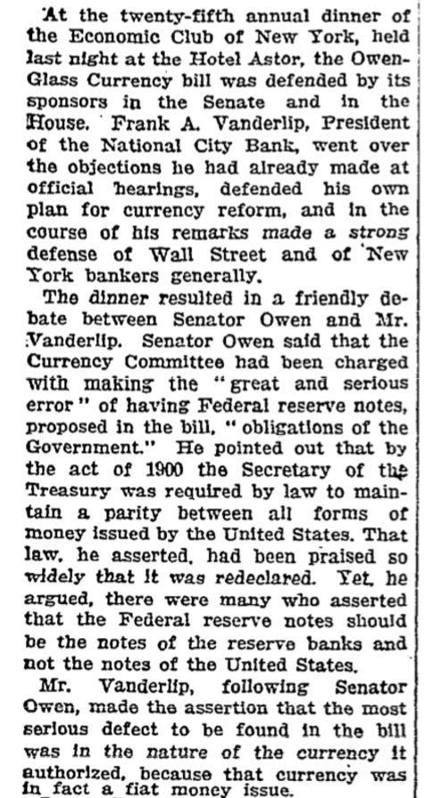
This is an interesting article to read since it is the debate within the ruling elites, discussing how they should design this new system and the problem of the temptations of fiat currencies! It is now almost Thanksgiving. 11/11/1913 [which] also happens to be a magic number day of great significance to the various secret societies. Bush Sr. made his infamous 'New World Order' speech on 9/11/1991, for example. So the fact that the people who belong to several interlocking societies and organizations chose this day for the debate is quite significant to me. [Well, that’s you!] They were performing the actions which we call 'magic'. Using numbers, the calendar, the position of the stars, etc, they basically 'chanted' for that which they wanted. This is 'dream making' of very ancient sort. By lining up codes and lining up systems so they fit into a magical framework, the hope is that reality will conform to desires. This is the basis of wizardry.
Flying under the radar of Christian or Jewish faith is this alternative, magical belief system. It does pop out into the open once and a while. But mostly, it is very subterranean. The system, by the way, has been breaking down in the last 50 years. But it still endures. And has been taken over partially by Osama Bin Laden. He is evidently aware of the magic number system.
Whenever I veer off into this area, some people are puzzled. They wonder why I am so intent on this. It is simple: my own ancestors helped design and create this system. And we are very involved in the place where all this comes together, the place we call 'The Outer Darkness.' Since this is also where the Dragon of Wealth lives, anyone seeking wealth has to approach it. Note how many rich people in America and elsewhere today get very rich building a doomsday machine which can turn our planet into a dead rock? This is something that amuses the Dragon greatly. The creation of the Federal Reserve was very much a part of this system set into motion to kill all humans. When rich men and women pray to the Dragon for wealth, they are actually praying to the Death Gods.
December 20, 1913,
CURRENCY BILL PASSES SENATE
Owen Measure Adopted, 54 to 34, Six Republicans and One Progressive Supporting It. TRIUMPH FOR PRESIDENT Hitchcock's Substitute Measure, Offered as a Test of Strength, Beaten on Earlier Vote. CONFERENCE MEETS TO-DAY La Follette's Radical Amendment Barring Congressmen from Serving on Bank Boards Accepted. CURRENCY BILL PASSES SENATE
The second great item on President Wilson's heavy legislation programme entered upon its final stage of enactment to-night when the Senate passed the Owen-Glass Currency bill by the overwhelming vote of 54 to 34. Though the measure carried a radical amendment, sponsored by Senator La Follette of Wisconsin, every Democrat present voted for it, and six Republicans -- both regular and progressive -- and one Progressive Party Senator joined them.
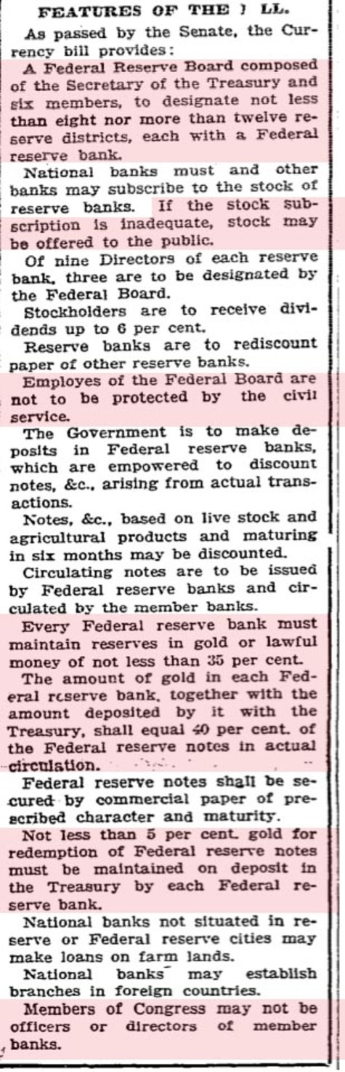
The Progressives thought they won when the[y] hauled into the Senate, the Trojan Horse. They thought, if they pass all sort of hedges, rules and regulations, this would prevent the investment bankers from controlling the currency and unilateral, secret rule. How sad is this?
I put in red the parts that the Progressives passed which were destroyed as swiftly as possible. First of all, note the minor role the Treasury Secretary plays today. The position of primacy intended by the passage of this Trojan Horse bill makes it clear, the President puts into power, the Treasury Secretary and HE runs the Federal Reserve! How did the rich people wrest away this power?
HAHAHA. Note the next part I put in red: 'If the stock subscription is inadequate, stock may be offered to the public.' Now, the 'public' in this case who were capable of buying stock in the Federal Reserve was very small indeed. It was the rich banker/investors themselves! And this was the opening they needed to take over the system and control it from within. Note also how careful this new entity is to keep it outside of the Civil Service laws. The opening story here about that recent court ruling is proof that this was intended to keep the Federal Reserve out of the control of the public.
All the rest of the highlighted parts of this newspaper article are things the Federal Reserve chucked out of the window over the last 100 years. With NO votes, NO debate, NO feedback from the populace at large. This is why we can witness a total breakdown in our entire banking system and not one candidate for President except for two who were eliminated instantly, Kucinich and Ron Paul, were willing to discuss. The media was dead set against ANY discussion about ANY of this! Instead, we bounce along going steeply downhill while the media constantly tells us, all will be going uphill thanks to the magicians at the Federal Reserve who will save us.
Back to the top story
1,2] There are no sharp criteria for determining whether an entity is a federal agency within the meaning of the Act, but the critical factor is the existence of federal government control over the "detailed physical performance" and "day to day operation" of that entity. . . . Other factors courts have considered include whether the entity is an independent corporation . . ., whether the government is involved in the entity's finances. . . ., and whether the mission of the entity furthers the policy of the United States, . . . Examining the organization and function of the Federal Reserve Banks, and applying the relevant factors, we conclude that the Reserve Banks are not federal instrumentalities for purpose of the FTCA, but are independent, privately owned and locally controlled corporations.
Each Federal Reserve Bank is a separate corporation owned by commercial banks in its region. The stockholding commercial banks elect two thirds of each Bank's nine member board of directors. The remaining three directors are appointed by the Federal Reserve Board. The Federal Reserve Board regulates the Reserve Banks, but direct supervision and control of each Bank is exercised by its board of directors. 12 U.S.C. Sect. 301. The directors enact by-laws regulating the manner of conducting general Bank business, 12 U.S.C. Sect. 341, and appoint officers to implement and supervise daily Bank activities. These activites include collecting and clearing checks, making advances to private and commercial entities, holding reserves for member banks, discounting the notes of member banks, and buying and selling securities on the open market. See 12 U.S.C. Sub-Sect. 341-361.
One thing that strikes me over and over again is the incestuous relationship the Fed has with itself. It is perfectly clear from the news about the passage of the Owen Glass Act that Congress intended for THEM [Congress] to decide who runs and who operates the Federal Reserve. Yet here we are, 100 years later, and the Fed gets to choose within itself, who runs it! Now we are in danger of the Fed taking over ALL the government functions for controlling our economy.
From the recent court case declaring the Fed is not part of the Fed:
H.R. Report No. 69 Cong. 1st Sess. 18-19 (1913).
The fact that the Federal Reserve Board regulates the Reserve Banks does not make them federal agencies under the Act. In United States v. Orleans, 425 U.S. 807, 96 S.Ct. 1971, 48 L.Ed.2d 390 (1976), the Supreme Court held that a community action agency was not a federal agency or instrumentality for purposes of the Act, even though the agency was organized under federal regulations and heavily funded by the federal government. Because the agency's day to day operation was not supervised by the federal government, but by local officials, the Court refused to extend federal tort liability for the negligence of the agency's employees. Similarly, the Federal Reserve Banks, though heavily regulated, are locally controlled by their member banks. Unlike typical federal agencies, each bank is empowered to hire and fire employees at will. Bank employees do not participate in the Civil Service Retirement System. They are covered by worker's compensation insurance, purchased by the Bank, rather than the Federal Employees Compensation Act. Employees travelling on Bank business are not subject to federal travel regulations and do not receive government employee discounts on lodging and services.
The Banks are listed neither as "wholly owned" government corporations under 31 U.S.C. Sect. 846 nor as "mixed ownership" corporations under 31 U.S.C. Sect. 856, a factor considered is Pearl v. United States, 230 F.2d 243 (10th Cir. 1956), which held that the Civil Air Patrol is not a federal agency under the Act. Closely resembling the status of the Federal Reserve Bank, the Civil Air Patrol is a non-profit, federally chartered corporation organized to serve the public welfare. But because Congress' control over the Civil Air Patrol is limited and the corporation is not designated as a wholly owned or mixed ownership government corporation under 31 U.S.C. Sub-Sect. 846 and 856, the court concluded that the corporation is a non-governmental, independent entity, not covered under the Act.
Additionally, Reserve Banks, as privately owned entities, receive no appropriated funds from Congress. . . .
And there it is: over a century of litigation that always did the same thing: reduced public powers over the Federal Reserve and increasing private controls over the Federal Reserve. This insidious process is part of the whole Trojan Horse system. All they needed was to get this thing started and bit by bit, they took over the system and then isolated it from all government controls. The final steps are now in motion. Americans, frightened by the effects of the banking mess CREATED BY THE FEDERAL RESERVE ITSELF are now going to be herded into supporting a TOTAL COUP by the same criminals who are doing this to us. The ancient story that is over 2,500 years old about the fox telling the birds to move into his cave so they can be safe, is exactly how things are today.
We are being told, if we move into the Cave of Death, the pirates, bankers, rich people who live in this cave on their beds of gold, will protect us, not eat us. Anyone who imagines they won't utterly enslave and cannibalize us is innocently walking into a trap. When the Trojan Horse was hauled into Troy, Cassandra tried to burn it down. She was stopped. The warriors inside emerged while everyone was asleep and slaughtered, raped and enslaved all the people. Sparing none.
Email this post
Culture of Life News Main Page

Choose a language to translate this page!
April 02, 2008 | Permalink

TrackBack
TrackBack URL for this entry:
http://www.typepad.com/t/trackback/763647/27690426
Listed below are links to weblogs that reference Federal Reserve History:

Comments
The US Congress is made up of a bunch of dumbshits. They want to not have to take any responsibility for anything whatsoever.
Elijah Cummings just referred to Bernanke as a "Superstar"
Posted by: JZ | April 02, 2008 at 11:45 AM
No, they're not dumbshits. They're evil, corrupt, traitorous and paid-off.
Posted by: John | April 02, 2008 at 01:53 PM
Interesting read in Bloomberg on the Fed handover of Bear Stearns to JP Morgan:
Fed Should Clarify Link to Bear Stearns Assets: Caroline Baum
April 2 (Bloomberg) -- When the Federal Reserve brokered a weekend deal last month for JPMorgan Chase & Co. to purchase Bear Stearns Cos. before it collapsed, many of the terms of the agreement were murky...
At the time, the Fed said it was taking control of the $30 billion portfolio, that it wasn't purchasing the assets. The Fed was assuming the risk if the eventual liquidation of the securities produced further losses -- losses that accrue to the taxpayer since the Fed turns over its profits to the U.S. Treasury. It also stood to benefit if the portfolio appreciated in value.
That doesn't pass the lender duck test. Lenders don't profit from the appreciation of an asset against which they extend credit. Only an equity owner does.
``They get the residual -- that almost always defines ownership,'' said Paul DeRosa, a partner at Mt. Lucas Management Co. ``The disclaimer of ownership is purely semantic.''
If the Fed is the residual owner of these securities, which seems likely based on its assumption of both risk and reward, it could be in violation of its charter. According to the 1913 Federal Reserve Act, which has been amended over the years, the Fed can buy U.S. Treasury and agency securities, foreign government securities, bankers acceptances, bills of exchange, certain municipal debt, foreign currency and gold.
http://www.bloomberg.com/apps/news?pid=20601039&sid=anrpWCiZbYxQ&refer=home
Posted by: rockpaperscizzors | April 02, 2008 at 02:23 PM
cont'd....Ownership Society
Nothing in there about collateralized debt obligations, private mortgage-backed securities or other derivatives of questionable quality.
Of course, if the Fed structured its loan as a ``discount'' -- the Fed is authorized to discount drafts, notes and bills of exchange, redeeming them at maturity -- then it would be a lender and a residual owner, said Vince Reinhart, former director of the Fed's Monetary Affairs Division and now a scholar at the American Enterprise Institute in Washington.
Most of today's loans from the Fed are ``advances,'' secured by ``acceptable collateral'' (the level of acceptability keeps declining). The collateral is returned to the borrower after a specified time.
If it seems like a distinction without a difference, it is.
``From an economic perspective, they are the residual claimant,'' Reinhart said. ``They have equity ownership.''
In the spirit of increased transparency, why can't the Fed come out and say that?
Fact(less) Sheet
On March 24, the New York Fed posted a summary of the terms and conditions of the loan on its Web site. In essence, the Fed created an off-balance sheet vehicle -- specifically a Delaware limited liability company -- to hold illiquid securities, and with no capital, funded by a $29 billion loan from the Fed and a subordinated $1 billion loan from JPMorgan, Reinhart said.
The Fed is nothing if not a quick study.
BlackRock Inc. has been retained as the manager.
The summary outlined the maturity of the loan (10 years, renewable at the discretion of the New York Fed); the interest rate on the loan (the primary credit rate, currently 2.5 percent, on the Fed loan; the primary credit rate plus 4.5 percent for JPMorgan); and the repayment terms. It skirted the ownership issue other than to say in the last line that ``any remaining funds resulting from the liquidation of the assets will be paid to the New York Fed.''
Legal Cover
Watching the evolution of Fed policy in the last six months from focused on inflation to fearful of systemic risk; the series of aggressive, rapid-fire rate cuts; the creation of an alphabet soup of new lending facilities; and the orchestration of a fire sale of Bear Stearns to JPMorgan, one has to wonder about the Fed's M.O. It all has a make-it-up-as-you-go-along quality.
Faced with what it thought would be a series of cascading financial failures if Bear Stearns went down, the Fed probably knew what it wanted to do, knew it had to do it quickly, and then had to figure out ``how to get it done within the confines of its legal structure,'' DeRosa said. ``The Fed used legal sleight of hand to reconcile what they wanted to do with what they're permitted to do by law.''
Bernanke is sure to be grilled about his actions when he testifies before the Joint Economic Committee of Congress today and the Senate Banking Committee tomorrow. A wee bit more transparency would be nice.
Then again, if the Fed is acting first and finding legal cover later, there's a benefit to keeping the details murky.
Posted by: rockpaperscizzors | April 02, 2008 at 02:25 PM
agree. now, how can i make some dough the honest way, and plow it into gold and community investment... sigh
Posted by: finop | April 02, 2008 at 02:35 PM
Many interesting things have been brought together in your latest. Numbers, having an influence other than being mere quantities, are a function of the construction of the cosmos/universe. Apparently these can be used for good or evil and are mostly the private reserve of the secret cabals.
Scientists have discovered and wondered over various unique 'constants' which appear in established natural law. Check out the website markrodin.com for a totally new take on number theory that is having the scientists/mathematicians taking notice and is clearly not yet mentioned in our educational venues.
Speaking of dragons and caves and monetary matters reminds one of warnings given long ago of the dark masters mentioned in the last book of the Bible who use merchandise as a hook and become ecstatic over ultimate and universal control by promoting destruction. Seems to fit the scenario developing today. How do we thank the remote viewers of 2000 or 2500 years ago?
When addressing the validity of Christian or Jewish or even Islamic faith, it is wise to consider who or what has inserted itself as the inspiring entity at the center of these faiths. The early Christian faith was very soon eclipsed by the so-called church fathers' traditions. For those wanting the real story from a marvelous academic of the last century who researched this question and still remains the unchallenged authority, please check out the book ' Marcion, The Gospel of the Alien God' by Adolph von Harnack. It is considered heretical! You'll love it, Elaine.
Posted by: RB | April 02, 2008 at 03:23 PM
Elaine, I believe this is your most important post EVER.
Most alternative news sites are basically just like sportscasters calling the play by play of these guys looting the country without any comprehension or analysis of why.
I find play by play of baseball, football and looting of the country to be interesting for a short while until you realize you are losing all the time and finally realize the games are rigged.
But you are right when you noted that your attempts to explain anything like this to the masses is pointless as they do not understand or care. The would rather watch WWF 'sports' or Jim Cramer on TV.
But I believe it is critical to get this information back into the thought stream of intelligent people who care, like most your readers, before we are all fed into the wood chipper.

Posted by: GK | April 02, 2008 at 04:38 PM

